

NASEI Acquisition NUC for RSV *Nuyina*

Australia’s National  
Science Agency

2024

Contents

1 Summary 1

1.1 Project Description 1

2 Implementation 1

2.1 Hardware 2

2.2 Software 2

2.2.1 BIOS 2

2.2.2 OS 2

2.2.3 OpenRVDAS 2

3 Bench Test 3

Appendix A Images 4

Appendix B Issue Register 5

Appendix C Data Stream Documentation 6

# Summary

CSIRO is managing an air sampling facility that is to be installed in the forward compartments of the Australian Antarctic Division's icebreaker, RSV *Nuyina*. The sensor suite is supported by peripheral equipment that assists with monitoring and management, called the Nuyina Air Sampling Enabling Infrastructure (NASEI). The data from this system needs to be collated and made available to the technical personnel on RSV *Nuyina*. To this end an Intel NUC will be installed in the air sampling space which will collect data from within an instrumentation private network and make it available to the AAD *Science Data Network*.

## Project Description

The NUC is configured with Rocky Linux 8 as the AAD preferred operating system. It has wheel (sudo) users for both CSIRO and AAD staff. CSIRO-SIT may want to configure it with supervisor scripts that allow it to monitor and initiate sampling for specific equipment.

The NUC also has an instance of OpenRVDAS with a configuration that ingests UDP broadcasts from the monitoring equipment, records them, and rebroadcasts onto the broader *Nuyina* network. It is essentially a multi-network data-broker.

# Implementation

Peripheral devices will transmit UDP messages to the NASEI NUC with a private network in the 192.168.0.1/24 address space. On the NASEI NUC an OpenRVDAS instance will collate the broadcasts, record them locally, and then rebroadcast to the *Science Data VLAN* on port 61404.

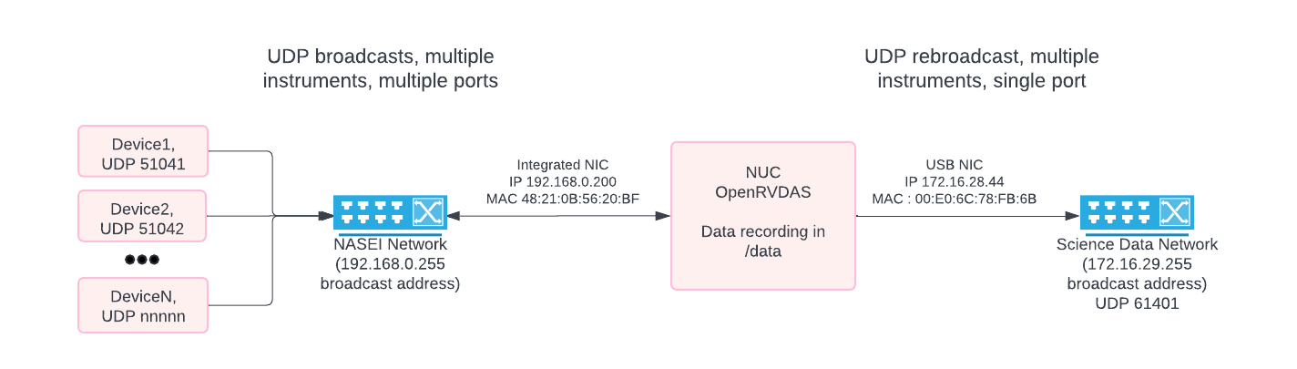

Figure 1 Overview of the implementation; UDP broadcasts collated by NUC, retransmitted into AAD-space

## Hardware

|  |  |
| --- | --- |
| Product Code | NUC13ANHi3000 (tall kit) |
| Integrated LAN MAC | 48:21:0B:56:20:BF (NASEI network) (2.5Gbps) |
| USB Ethernet Adapter MAC | 00:E0:6C:78:FB:6B (AAD network) (1Gbps) |
| Wifi MAC | 98:59:7A:95:11:27 |
| PSU | 90.06W (19.0V 4.74A) |
| Serial Number | BTAN30800E8B |
| OS | Rocky Linux 8.10 |
| User Accounts | root, nasei, rvdas, marine |
| RAM | 16GB |
| Processor | I3-1315U x8 |
| Boot Disk | 250GB WD Blue SN570 |
| Data Disk | 1TB WD Blue SA510 2 |

## Software

### BIOS

The NUC has been configured to resume previous state after power loss, therefore is there is an outage and the NUC is not backed by a UPS it should resume operation when power is supplied again.

### OS

The NUC is running Rocky Linux 8.10. The firewall has been opened for UDP ports 50000-65000.

sudo firewall-cmd --zone=public --add-port=50000-65000/udp --permanent

sudo firewall-cmd –reload

Network interfaces configured:

* Integrated ethernet for NASEI network: IP 192.168.0.200, netmask 255.255.255.0
* USB ethernet for RSV *Nuyina* network: DHCP (MAC address supplied to AAD for whitelisting)

The NUC has a 1TB SSD that is mounted at */data* on boot. This drive is used for recording the raw data from the system. The data drive is monitored by *tmpfiles*. This configuration is in */etc/tmpfiles.d/nasei-data-tmpfiles.conf*, and sets */data/raw* to have a 365-day endurance.

### OpenRVDAS

The default OpenRVDAS repository has been cloned to */opt/openrvdas* and the setup script has been run. The configuration for data transfer is set from the *nasei-openrvdas-config* repository (cloned to */home/rvdas/*), which needs to be handed off to either AAD or CSIRO. It is currently hosted at <https://github.com/angus-cummings/nasei-openrvdas-config> as it was not possible to create a public repository within the CSIRO bitbucket. Instructions for its use are in the README.rst and setup.sh.

### Supervisor and NASEI repo

This NUC has already been configured for supervisor daemon as a part of the OpenRVDAS setup script. NASEI should be able to add their own configuration in */etc/supervisord.d*. The NASEI SIT repo has been pulled into the nasei user home directory, a Python3.9 virtual environment has been commissioned, and the requirements have been installed. SIT will need to make changes as they implement control scripts for the infrastructure devices.

git clone ssh://git@bitbucket.csiro.au:7999/etsit/nasei.git /home/nasei/

cd /home/nasei/nasei

# Require Python3.9 for the dependencies in requirements.txt

sudo dnf install -y python3.9

python3.9 -m venv venv

. venv/bin/activate

pip install -r requirements.txt

Supervisor configurations for scripts should be added to /etc/supervisor.d/ with a .ini extension. The supervisor interface is accessible at <http://localhost:9001>. There is an example config to run a python script with the nasei venv in /etc/supervisor.d/time.ini which just writes the datetime to stderr once per second. Output can be viewed by clicking Tail -f Stderr on <http://localhost:9001>

# Bench Test

Benchtop testing was performed by using a spare NUC and the unit under test (UUT) with ethernet crossover patches between the NASEI network side and Science Data VLAN side of the UUT. The spare NUC was used with OpenRVDAS *simulate_data.py* to broadcast UDP on relevant ports and it was confirmed that the broadcasts were logged in */data/raw*. The UDP messages were also captured on the second NIC on the test NUC using *ngrep*. For this testing the AAD network side was allocated a static IP (172.16.28.2, 255.255.254.0) as it will be allocated by DHCP on the vessel.

1. Images

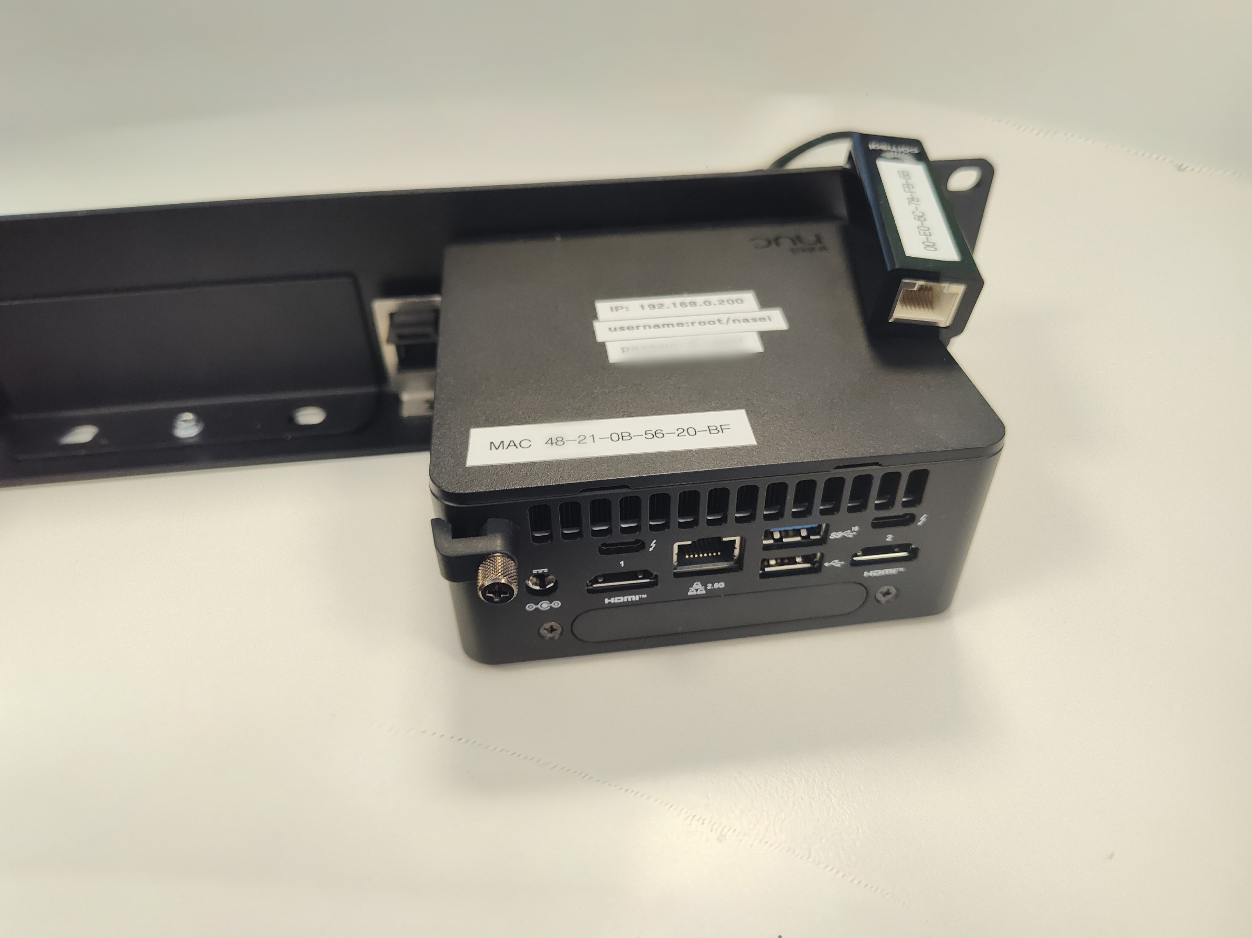

Figure 2 Back of NUC, rack interior

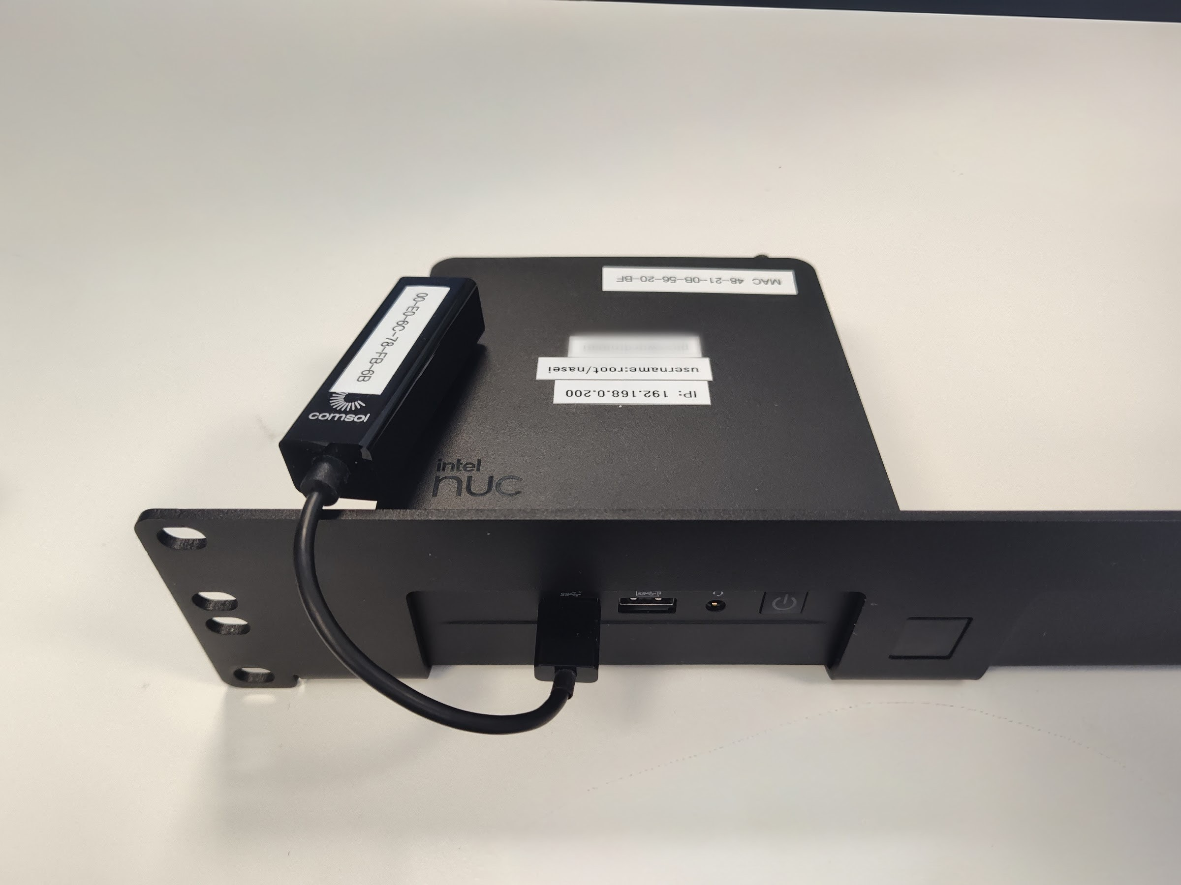

Figure 3 Front of NUC. The USB-Ethernet adapter can be connected to the front or back ports and will be fastened with hook and loop tape.

1. Issue Register
2. ~~The flatfiles have no rotation at this point in time. In theory the 1TB drive will eventually fill up and cause issues. This could be managed by using a temporary directory effect, where files have an endurance of one year (for example), or actively managed by AAD Technical Services or AADC.~~
   1. Addressed by *nasei-data-tmpfiles.conf* in */etc/tmpfiles.d*
   2. Currently configured for a 365-day file endurance in */data/raw*
3. A complete list of input instrumentation has not been provided by CSIRO-SIT. The file n*asei-port-definitions.yaml* needs to be populated and a new config generated when the information is available.
4. CSIRO-SIT will provide message definitions to AAD Technical Services when available. NB messages sent to VLAN28 on port 61401 will be prefixed with the source-instrument name before they reach AAD-OpenRVDAS, eg.

#{device} {record}

VFD2 $InletFlow2,2024-06-30 06:00:02,-0,40.0,10.0,2800.0,19.0,240.0,21.0

{

device: “VFD2”,

record: “$InletFlow2,2024-06-30 06:00:02,-0,40.0,10.0,2800.0,19.0,240.0,21.0”

}

1. Data Stream Documentation

The spreadsheet at [NASEI device data streams.xlsx](https://csiroau.sharepoint.com/:x:/s/NuyinaAirSamplingEnablingInfrastructureNASEI/EQwP5EnsxQhFokbc7iAAfycBWT1d8HNbdh1aVjaDYgXGPg?e=Bod7u1) is a work-in-progress outline of the devices within the NASEI infrastructure network.

|  |  |  |
| --- | --- | --- |
| As Australia’s national science agency and innovation catalyst, CSIRO is solving the greatest challenges through innovative science and technology.  CSIRO. Unlocking a better future for everyone.  Contact us  1300 363 400  +61 3 9545 2176  csiro.au/contact  csiro.au |  | For further information  Natl Collections & Marine Infrastructure  Steven van Graas +61 3 6232 5308  [steven.vangraas@csiro.au](mailto:steven.vangraas@csiro.au) |